

Ground water quality
CS 667: Machine learning

Final Project Report By:
Group – 17
Naralasetti Shanmukheswari Prasannasai
Srinivasa Chowdary Eluri
Christopher Kirkman
Divya Tanniru

Abstract: (done)
The quality of groundwater is critical for business, drinking water, and agriculture. But because of human activities like industrial discharges, agricultural runoff, and inadequate waste management techniques, it is becoming more and more endangered. This study investigates the classification and prediction of groundwater quality using machine learning techniques, particularly the Random Forest algorithm. By concentrating on data gathered from different Telangana, India, districts between 2018 and 2020 and utilizing the RFS model's capacity to handle complex, high-dimensional, nonlinear, and noisy datasets, the Random Forest model successfully identifies important predictors, such as Electrical Conductivity (E.C.) and Total Dissolved Solids (TDS), which are crucial for evaluating the quality of water. The model can successfully pinpoint contaminated sites and identify important influencing elements despite obstacles like data imbalance and high computing requirements. The study demonstrates how machine learning may improve the management of sustainable water resources. It provides insightful information that stakeholders and policymakers can use to resolve contamination concerns and safeguard groundwater supplies.

- Introduction: (done)
Groundwater is an essential resource that sustains industry, agriculture, and the drinking water needs of millions of people worldwide. Human activities like excessive agricultural runoff, the release of industrial waste, and the inappropriate disposal of hazardous chemicals, however, steadily raise the risk of contamination. In addition to degrading water quality, contaminants like pesticides, nitrates, and heavy metals also seriously endanger ecosystems, human health, and the sustainability of resources over the long run. Given that groundwater contamination is difficult to reverse, early detection and continuous monitoring are essential to mitigate risks and ensure safe and sustainable water usage.

The core problem addressed in this study is the classification and prediction of groundwater quality using advanced machine-learning techniques. Nonlinear interactions, large complexity, and substantial noise from missing or insufficient data are all inherent characteristics of groundwater databases. the Random Forest method which is known for its resilience and capacity to manage intricate and high-dimensional information is used in this study to categorize water quality and pinpoint important contributing variables. Analyzing groundwater quality trends in Telangana, India, from 2018 to 2020 is the main goal where groundwater is essential to agricultural and local life in this region.

This problem is particularly significant as groundwater quality directly affects crop yields, livestock health, and access to safe drinking water factors critical for sustainable development. By addressing issues such as rising salinity and contamination from dissolved solids, This study helps manage resources and promotes environmental preservation and public health by tackling problems such increasing salinity and dissolved solids contamination. This is a critical step in ensuring water security for future generations since it uses machine learning to deliver a scalable and data-driven solution to a growing problem.

- Related Work (done)
Machine learning has become essential in assessing groundwater quality, particularly through techniques like ensemble learning. Random Forest (RF), in particular, has gained attention for its ability to handle complex, noisy datasets effectively.

Haji Seyed Asadollah et al. (2021), in order to forecast the River Water Quality Index (RWQI) compared different machine learning models, including RF. Due to its capacity to capture intricate relationships between water quality measures including pH, turbidity, and dissolved oxygen, the results showed that RF performed better than other models, including Support Vector Machines (SVM) and Artificial Neural Networks (ANN). Plus, RF is great at quantifying uncertainty, which makes it a really good option for real-world environmental predictions.

Similarly, Torres-Martínez et al. (2024) focused on RF for groundwater quality prediction, addressing challenges like sparse data and the diverse nature of groundwater sources. Their work demonstrated RF's effectiveness in predicting nitrate and sulfate contamination, even in areas with limited monitoring. The model's capability to manage multi-dimensional datasets proved invaluable for understanding the relationships among different water quality parameters.
Overall, these studies highlight Random Forest as a powerful tool for evaluating water quality, making it a reliable option for improving monitoring and decision-making. This study further explores its application in predicting groundwater quality in Telangana, India, contributing to sustainable water resource management.

- Methods:
This study applies the Random Forest (RF) classifier and decision trees to classify and predict groundwater quality. because RF algorithm can handle complex interactions and non-linear data, which are features of geochemical and environmental datasets. Many factors impact groundwater quality and the Random Forest ensemble's decision trees are effective at capturing and modeling these relationships backward. In addition, it is quick to train, scalable, and able to handle missing values, which are frequently found in environmental data. Furthermore, Random Forest offers a feature importance ranking that is crucial to this project because it helps us determine which factors influence the classification of groundwater quality the most. This method will enable us to develop a reliable, generalizable model for accurately classifying groundwater quality

  - Data Preprocessing

The dataset undergoes several preprocessing steps:

Handling Missing Values: Missing data can reduce the accuracy of the model so, handle missing values in columns such as pH and groundwater level (gwl) are imputed using the mean of the respective columns.

Clean redundant feature: Drop the unnecessary column like Unnamed: 8 to reduce noise
Label Encoding: Categorical features such as district, mandal, season, village, classification, and classification.1 are encoded using Label Encoding.

Normalization: Continuous variables, including pH, E.C, TDS, are normalized to ensure consistent scale across features.

3.2 Feature Selection
The most important factors affecting groundwater quality are determined using RF's feature significance function. Important characteristics, such Total Dissolved Solids (TDS) and Electrical Conductivity (E.C.), are ranked according to how they affect the categorization process.

3.3 Model Training and Testing
Training uses 80 percent of the dataset, with testing and validation using the remaining 20 percent. After training using training data, the performance of the RF model is evaluated using test data. Furthermore, we use k-fold cross-validation to provide resilience and prevent overfitting.

  - Evaluation Metrics

The metrics listed below are used to assess the model's performance:

Accuracy: The proportion of correctly predicted instances.

F1-Score, Precision, and Recall: Metrics that assess how well the model can categorize each groundwater quality class

Confusion Matrix: This tool shows the model's incorrect classifications.

ROC Curve: To evaluate how the true positive rate and false positive rate are traded off for multi-class categorization.

- Dataset:

We used "Telangana Groundwater Quality data" dataset from kaggle in this study, which has three different files that contains water quality data collected from various districts in Telangana between 2018 and 2020. Each file includes nearly 350 rows of samples and 27 columns of features, Such as identical identifiers like district, mandal, village and geochemical properties like pH, E.C, TDS. The key processing steps included is Handling missing values, label encoding and normalization
Water Quality Data [Telangana Groundwater]

- Results and evaluation:
  - Model Performance
The Random Forest model demonstrated strong performance in classifying groundwater quality. Key results include:
2018 Results:
(Accuracy rate screenshot)
- Accuracy: 0.92
- Classification Report:
- precision recall f1-score support

- 1 1.00 1.00 1.00 14
- 3 0.98 1.00 0.99 51
- 4 0.00 0.00 0.00 0
- 5 0.00 0.00 0.00 2
- 7 0.60 1.00 0.75 3
- 8 0.00 0.00 0.00 2
- 10 1.00 0.33 0.50 3

- accuracy 0.92 75
- macro avg 0.51 0.48 0.46 75
- weighted avg 0.92 0.92 0.91 75

(And related explanation)
2019 Results:
(Accuracy rate screenshot)
- Accuracy: 0.9452054794520548
- Classification Report:
- precision recall f1-score support

- 1 1.00 1.00 1.00 19
- 2 0.96 1.00 0.98 43
- 3 0.00 0.00 0.00 1
- 4 0.78 0.88 0.82 8
- 5 0.00 0.00 0.00 2

- accuracy 0.95 73
- macro avg 0.55 0.57 0.56 73
- weighted avg 0.91 0.95 0.93 73
- weighted avg 0.92 0.93 0.92 74
(And related explanation)
2020 Results:
(Accuracy rate screenshot)
- Accuracy: 0.8783783783783784
- Classification Report:
- precision recall f1-score support

- 0 1.00 1.00 1.00 18
- 1 0.98 1.00 0.99 42
- 2 0.00 0.00 0.00 0
- 3 0.00 0.00 0.00 3
- 4 0.50 1.00 0.67 5
- 5 0.00 0.00 0.00 3
- 7 0.00 0.00 0.00 1
- 8 0.00 0.00 0.00 2

- accuracy 0.88 74
- macro avg 0.31 0.38 0.33 74
- weighted avg 0.83 0.88 0.85 74
(And related explanation)
  - Confusion Matrices
2018
(Confusion Matrices screenshot)
Training Confusion Matrix:
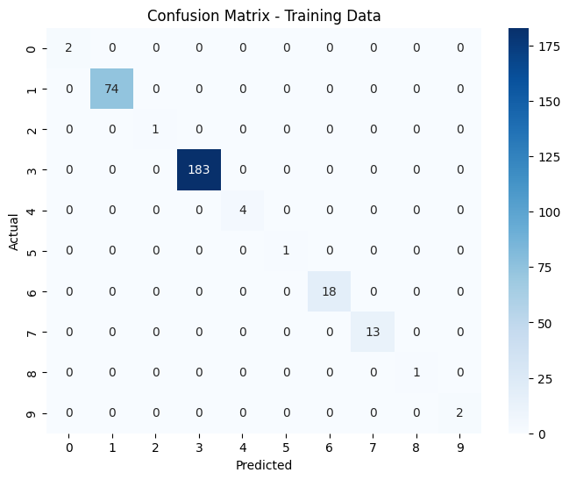
Testing Confusion Matrix:
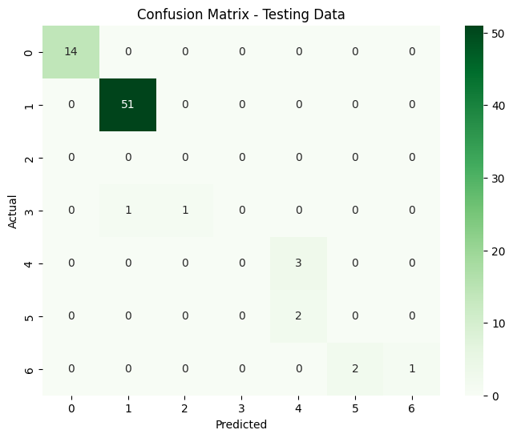

(And related explanation)
Training Confusion Matrix:
The model performs exceptionally well on the training data with no misclassifications.However, this could indicate overfitting, especially if the test or validation confusion matrix reveals poorer performance
Testing Confusion Matrix:
Exhibits considerably strong performance, as the model performs well for Classes 0, 1, and 4 with high precision and recall.But model does show that it struggles with minority classes as The model misclassifies instances of Classes 4, and 1. Classes 3,5 and 6 having little to no correct classifications, indicating that these classes are underrepresented in the training data or have features that overlap with other classes.
2019:
(Confusion Matrices screenshot)
Training Confusion Matrix:
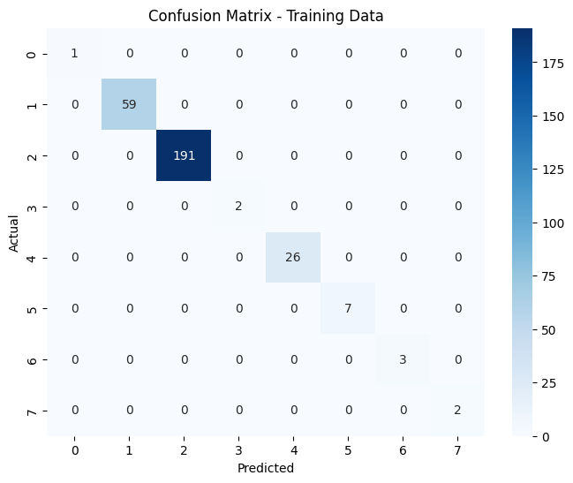
Testing Confusion Matrix:
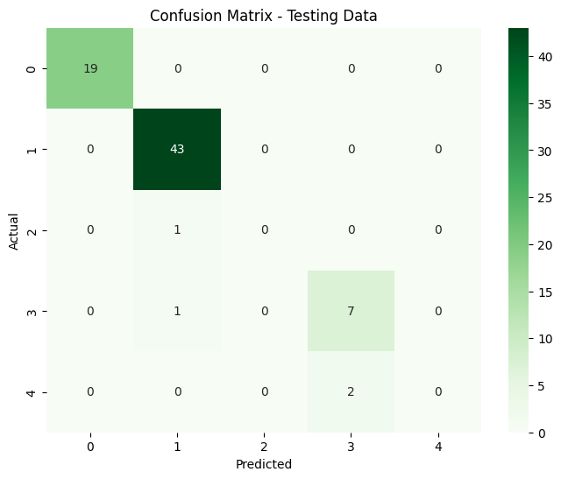
(And related explanation)
Training Confusion Matrix:
The model performs exceptionally well on the training data with no misclassifications.However, this could indicate overfitting, especially if the test or validation confusion matrix reveals poorer performance
Testing Confusion Matrix:
Exhibits considerably strong performance, as the model performs well for Classes 0, 1, and 3 with high precision and recall.But model does show that it struggles with minority classes as The model misclassifies instances of Classes 2, and 4. Classes 2 and 4 have no correct classifications, indicating that these classes are underrepresented in the training data or have features that overlap with other classes.
2020:
(Confusion Matrices screenshot)
Training Confusion Matrix:
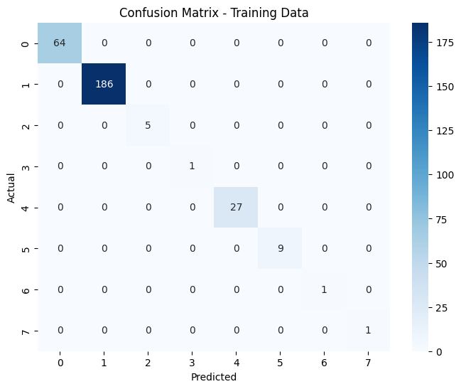
Testing Confusion Matrix:
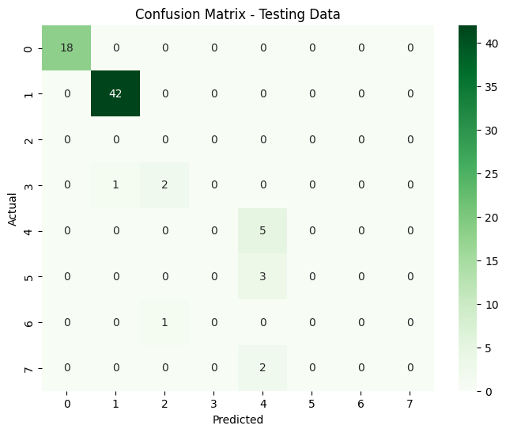

(And related explanation)
Training Confusion Matrix:
The model performs exceptionally well on the training data with no misclassifications.However, this could indicate overfitting, especially if the test or validation confusion matrix reveals poorer performance
Testing Confusion Matrix:
Exhibits considerably strong performance, as the model performs well for Classes 0, 1, and 4 with high precision and recall.But model does show that it struggles with minority classes as The model misclassifies instances of Classes 4, and 1. Classes 3,5 and 6 having little to no correct classifications, indicating that these classes are underrepresented in the training data or have features that overlap with other classes.
  - Feature importance
2018
(Feature importance screenshot)
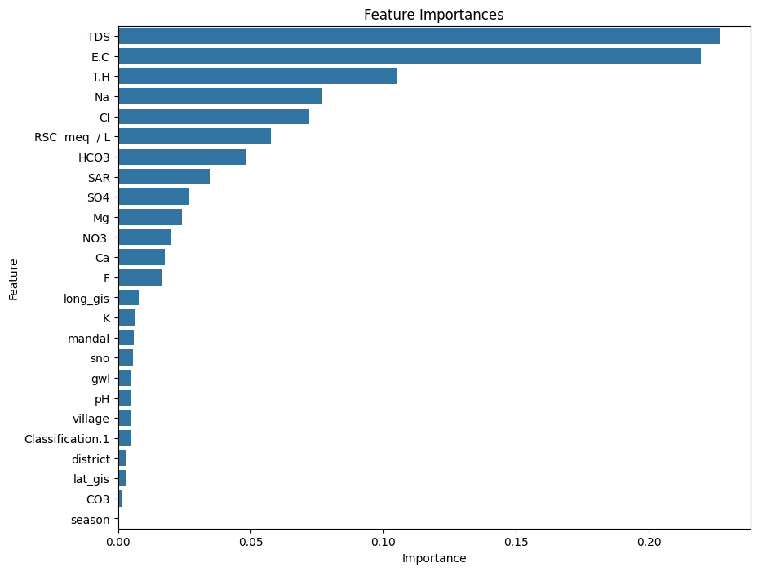
(And related explanation)
Top Features of Importance: TDS and EC
2019:
(Feature importance screenshot)
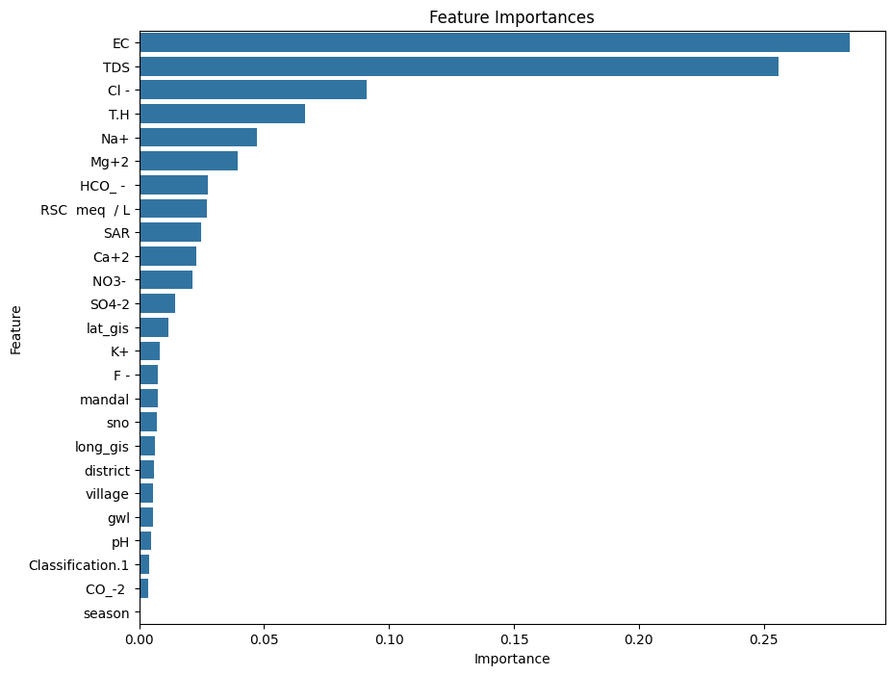
(And related explanation)
Top Features of Importance: EC and TDS
2020:
(Feature importance screenshot)
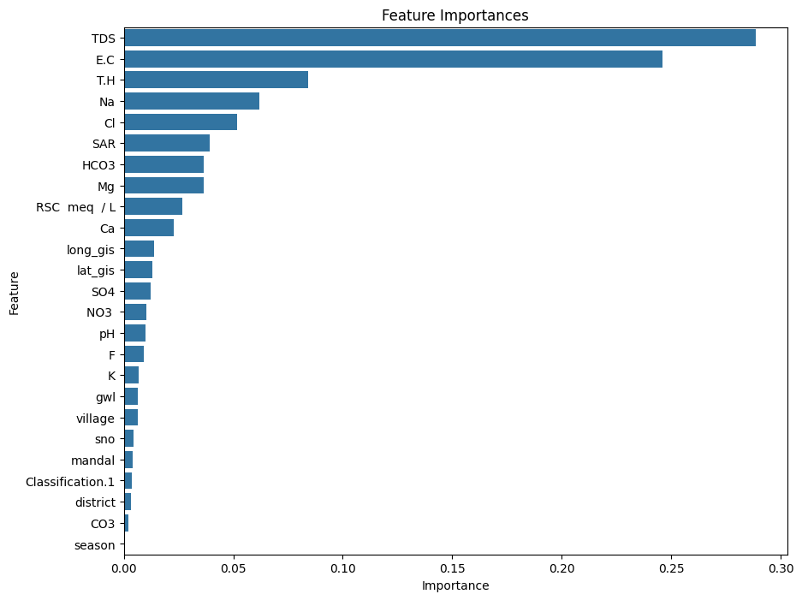
(And related explanation)
Top Features of Importance: TDS and EC
  - ROC curve
2018
(ROC curve screenshot)
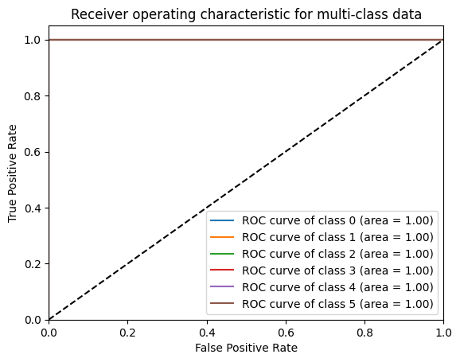
(And related explanation)
Maintains placement in the middle of of the graph indicating model is generalizing well good performance of a classifier and not overfitting
2019:
(ROC curve screenshot)
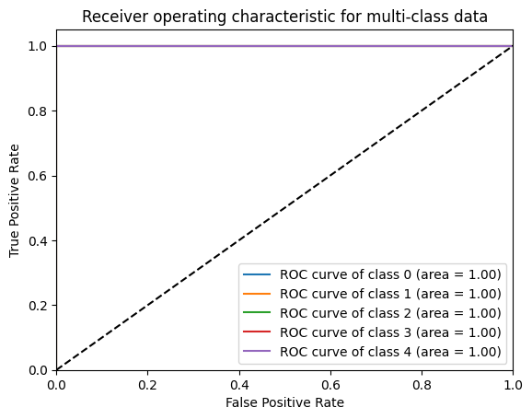
(And related explanation)
Maintains placement in the middle of of the graph indicating model is generalizing well good performance of a classifier and not overfitting
2020:
(ROC curve screenshot)
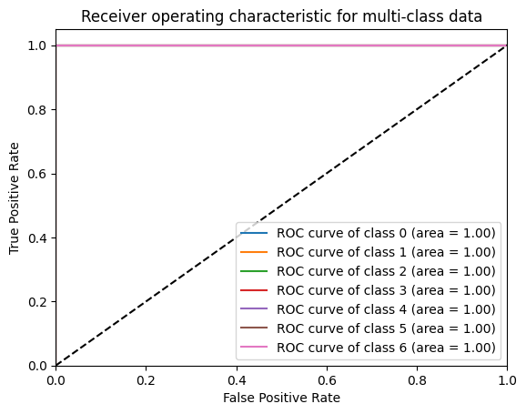
(And related explanation)
Maintains placement in the middle of of the graph indicating model is generalizing well good performance of a classifier and not overfitting
  - Learning curves
2018
(learning curve screenshot)
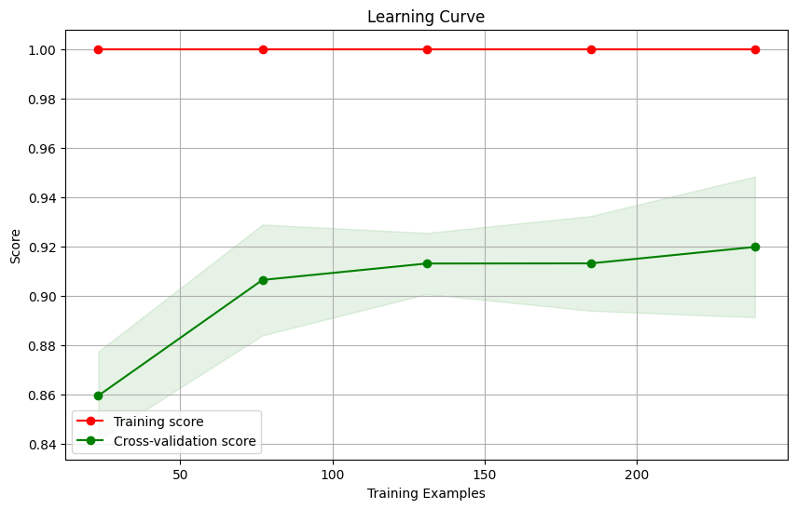
(And related explanation)
High training and cross-validation scores indicate good generalization.A small gap between the curves suggests minimal overfitting.Flat, training curve, Cross-Validation starts at 86% plateaus out then increases and stops at 92%.The plateau in the cross-validation score suggests the model has reached its maximum capacity, and adding more data may not provide significant improvements.
2019:
(learning curve screenshot)
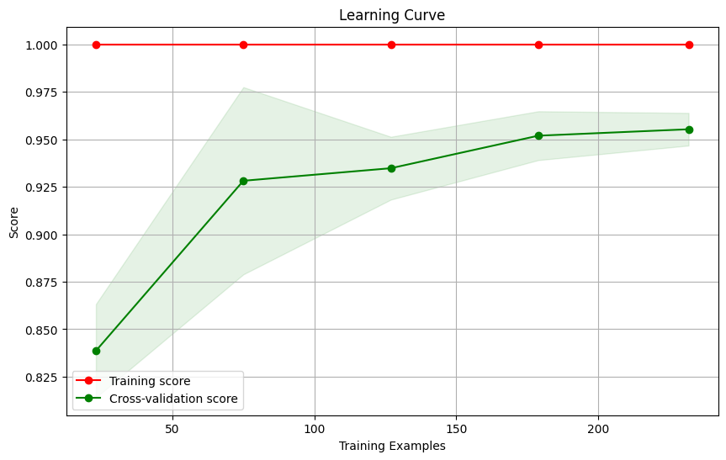
(And related explanation)
High training and cross-validation scores indicate good generalization.A small gap between the curves suggests minimal overfitting.Flat, training curve, Cross-Validation starts at 83% plateaus out then increases and stops at 95%.The plateau in the cross-validation score suggests the model has reached its maximum capacity, and adding more data may not provide significant improvements.
2020:
(learning curve screenshot)
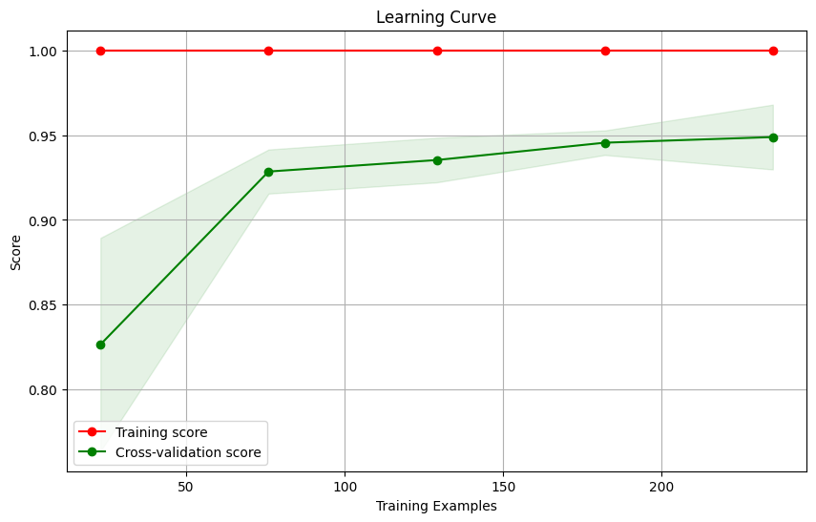
(And related explanation)
High training and cross-validation scores indicate good generalization.A small gap between the curves suggests minimal overfitting.Flat, training curve, Cross-Validation starts at 83% plateaus out then increases and stops at 95%.The plateau in the cross-validation score suggests the model has reached its maximum capacity, and adding more data may not provide significant improvements.
  - Decision Boundary
2018
(Decision boundary screenshot)
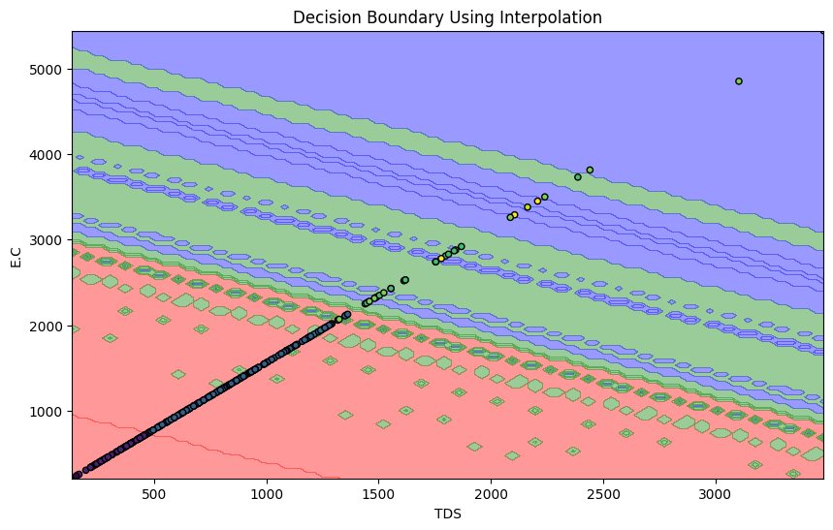
(And related explanation)

Large Concentration of data points lie in the Red and and Blue Regions but water overall during this Time period maintained good to moderate quality.

2019:
(Decision boundary screenshot)
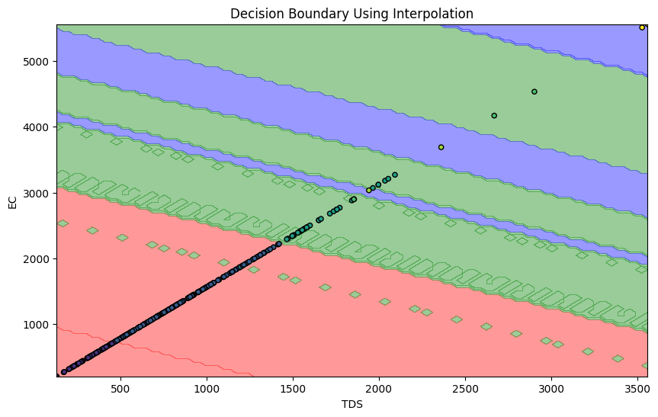
(And related explanation)
Large Concentration of data points lie in the Red and and Green Regions indicating overall good to moderate quality of water for this Time period.
2020:
(Decision boundary screenshot)
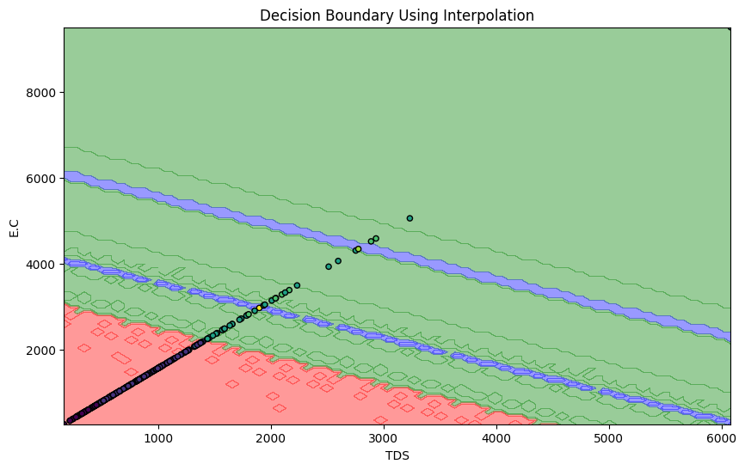
(And related explanation)
Large Concentration of data points lie in the Red and and Green Regions indicating overall good to moderate quality of water for this Time period.

- Conclusion:
- Separating into the three regions Red,Green, and Blue by looking at these areas as laid out in the Decision Boundary and taking a look at the feature values of the data points in those said regions we are able to gain insight and valuable information into what the exact quality of the water is.
- Knowing the safe threshold limits for safe wafe quality is when the TDS levels do not exceed 500 mg/L limit, and the E.C. level don’t exceed the 1000 µS/cm limit.
- The Red Region likely represents good water quality
As we got result like these over the 3 year time period
2018:
Feature Importance Values:
Feature Importance
10 TDS 0.228785
9 E.C 0.223455

Top 2 Features: ['TDS' 'E.C']

Feature Ranges for Each Region:

Red Region (0):
TDS E.C
count 2.000000 2.00000
mean 144.640000 226.00000
std 12.671354 19.79899
min 135.680000 212.00000
25% 140.160000 219.00000
50% 144.640000 226.00000
75% 149.120000 233.00000
max 153.600000 240.00000

2019:
Feature Importance Values:
Feature Importance
10 TDS 0.276659
9 EC 0.212198

Top 2 Features: ['TDS' 'EC']

Feature Ranges for Each Region:

Red Region (0):
TDS EC
count 1.0 1.0
mean 131.2 205.0
std NaN NaN
min 131.2 205.0
25% 131.2 205.0
50% 131.2 205.0
75% 131.2 205.0
max 131.2 205.0

2020:
Feature Importance Values:
Feature Importance
9 E.C 0.242452
10 TDS 0.211156

Top 2 Features: ['E.C' 'TDS']

Feature Ranges for Each Region:

Red Region (0):
E.C TDS
count 66.000000 66.000000
mean 573.681818 367.156364
std 119.756954 76.644450
min 324.000000 207.360000
25% 477.000000 305.280000
50% 580.000000 371.200000
75% 678.750000 434.400000
max 745.000000 476.800000

- The Green Region likely represents moderate to poor water quality. We saw slightly elevated TDS and E.C. which would suggest water quality is starting to degrade.Which could be a indicator of potential sources of salinity or contamination
As we got result like these over the 3 year time period
2018:
Feature Importance Values:
Feature Importance
10 TDS 0.228785
9 E.C 0.223455

Top 2 Features: ['TDS' 'E.C']

Feature Ranges for Each Region:

Green Region (1):
TDS E.C
count 77.000000 77.000000
mean 351.177143 548.714286
std 88.751827 138.674729
min 160.000000 250.000000
25% 270.080000 422.000000
50% 371.200000 580.000000
75% 431.360000 674.000000
max 479.360000 749.000000

2019:
Feature Importance Values:
Feature Importance
10 TDS 0.276659
9 EC 0.212198

Top 2 Features: ['TDS' 'EC']

Feature Ranges for Each Region:

Green Region (1):
TDS EC
count 61.000000 61.000000
mean 346.512787 541.426230
std 85.668286 133.856697
min 171.520000 268.000000
25% 277.120000 433.000000
50% 354.560000 554.000000
75% 416.000000 650.000000
max 476.160000 744.000000

2020:
Feature Importance Values:
Feature Importance
9 E.C 0.242452
10 TDS 0.211156

Top 2 Features: ['E.C' 'TDS']

Feature Ranges for Each Region:

Green Region (1):
E.C TDS
count 180.000000 180.000000
mean 1289.672222 825.390222
std 389.418487 249.227832
min 758.000000 485.120000
25% 934.000000 597.760000
50% 1258.000000 805.120000
75% 1585.000000 1014.400000
max 2188.000000 1400.320000

- The Blue Region represents poor water quality.Significantly elevated TDS and E.C. values indicate contamination and poor water quality.Which indicates the need to treat water to reduce TDS and E.C. levels Identify and address contamination sources to improve water quality. E.C. and TDS are very high, indicating significant contamination
As we got result like these over the 3 year time period
2018:
Feature Importance Values:
Feature Importance
10 TDS 0.228785
9 E.C 0.223455

Top 2 Features: ['TDS' 'E.C']

Feature Ranges for Each Region:

Blue Region (2):
TDS E.C
count 1.0 1.0
mean 476.8 745.0
std NaN NaN
min 476.8 745.0
25% 476.8 745.0
50% 476.8 745.0
75% 476.8 745.0
max 476.8 745.0
2019:
Feature Importance Values:
Feature Importance
10 TDS 0.276659
9 EC 0.212198

Top 2 Features: ['TDS' 'EC']

Feature Ranges for Each Region:
Blue Region (2):
TDS EC
count 188.000000 188.000000
mean 841.004255 1314.069149
std 248.218303 387.841098
min 481.280000 752.000000
25% 640.160000 1000.250000
50% 801.920000 1253.000000
75% 1004.480000 1569.500000
max 1420.800000 2220.000000
2020:
Feature Importance Values:
Feature Importance
9 E.C 0.242452
10 TDS 0.211156

Top 2 Features: ['E.C' 'TDS']

Feature Ranges for Each Region:

Blue Region (2):
E.C TDS
count 3.000000 3.000000
mean 1519.666667 972.586667
std 110.228550 70.546272
min 1394.000000 892.160000
25% 1479.500000 946.880000
50% 1565.000000 1001.600000
75% 1582.500000 1012.800000
max 1600.000000 1024.000000
- Looking at the Overall trend on the water quality starting from 2018 to 2020 what we can see is while data points show that over the years they consistently lie in areas where there were consistently good to moderate water like red and green the areas were there moderate to poor quality of water had to continual decline. Starting off in 2018 with no contamination concerns, 2019 showed increases in salinity levels, ionic containat, and contamination from dissolved solids as TDS exceeded and EC exceeded threshold levels. As well in but overall water quality was good, 2020 showed increases in salinity levels, ionic containat, and contamination from dissolved solids as TDS exceeded and EC exceeded threshold levels. The Green Region shows a gradual decline, with moderate contamination observed by 2020. The Blue Region shifts from moderate to poor quality, indicating severe contamination. The deterioration in the Blue and Green Regions suggests increasing contamination from industrial, agricultural, or urban runoff.

- Reference:

Evaluation: The model’s performance declined slightly in areas with increasing contamination levels. However, it still provided valuable insights into contamination trends.

- 2020:
- Accuracy: 0.8783783783783784
- Classification Report:
- precision recall f1-score support

- 0 1.00 1.00 1.00 18
- 1 0.98 1.00 0.99 42
- 2 0.00 0.00 0.00 0
- 3 0.00 0.00 0.00 3
- 4 0.50 1.00 0.67 5
- 5 0.00 0.00 0.00 3
- 7 0.00 0.00 0.00 1
- 8 0.00 0.00 0.00 2

- accuracy 0.88 74
- macro avg 0.31 0.38 0.33 74
- weighted avg 0.83 0.88 0.85 74

- Quantitative Analysis: For analysis, we would use the Area under the ROC Curve to evaluate models in addition to the accuracy percentage, precision value, recall value, and F1-score as performance metrics.

-2020:
Training Confusion Matrix:
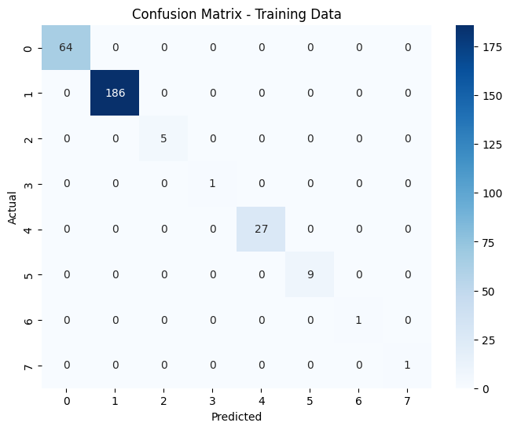
Explanation:

- The model performs exceptionally well on the training data with no misclassifications.
- However, this could indicate overfitting, especially if the test or validation confusion matrix reveals poorer performance

Test Confusion Matrix:
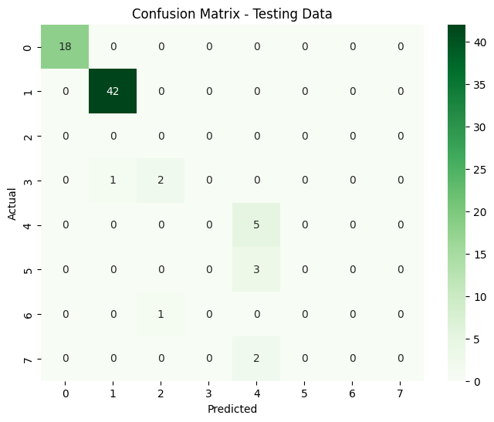
Explanation of the confusion matrix:
Strong Performance:
  - The model performs well for Classes 0, 1, 4, and 5 with high precision and recall.
  - These classes likely have more samples in the training data or are more distinct.
Struggles with Minority Classes:
  - The model misclassifies instances of Classes 3, 6, and 7.
  - Classes 6 and 7 have no correct classifications, indicating that these classes are underrepresented in the training data or have features that overlap with other classes.

ROC Curve:
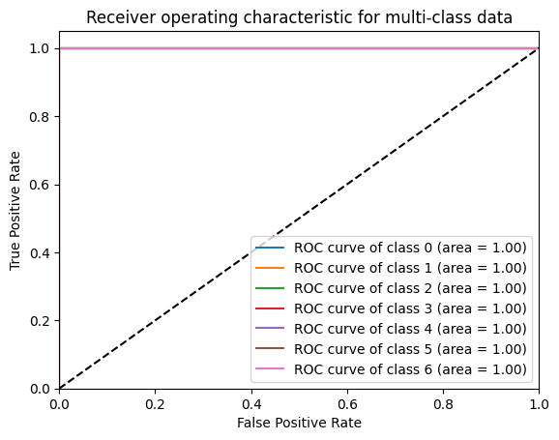
Explanation:
Maintains placement in the middle of of the graph indicating model is generalizing well good performance of a classifier and not overfitting

Feature Importance:
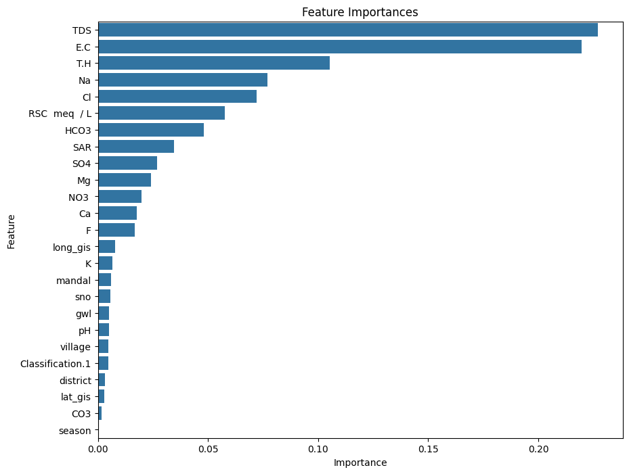
Explanation:
Top Features of Importance: TDS and EC

Learning Curve:
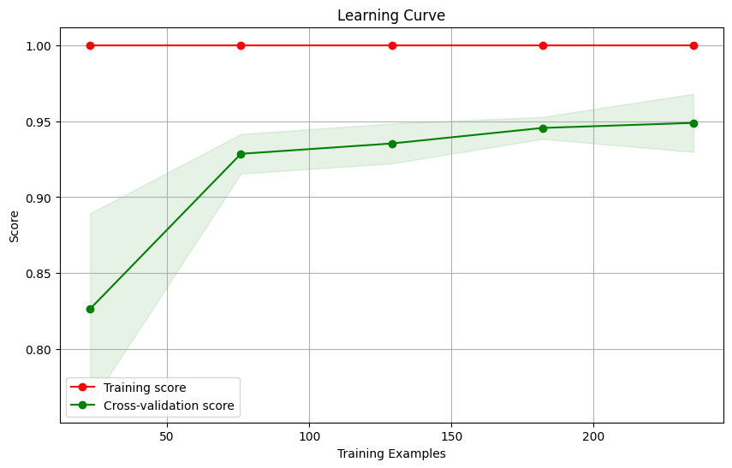
Explanation:
- High training and cross-validation scores indicate good generalization.
- A small gap between the curves suggests minimal overfitting.
- The plateau in the cross-validation score suggests the model has reached its maximum capacity, and adding more data may not provide significant improvements.

Precision Curve:

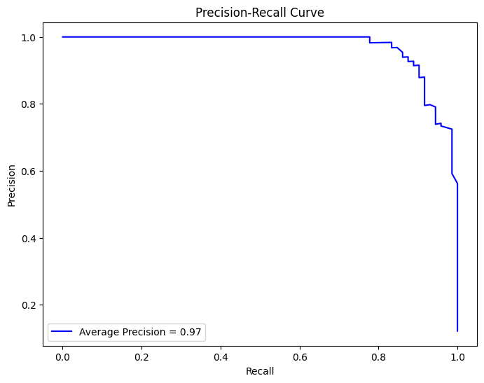
Explanation:
- Precision-Recall Curve:
  - Illustrates how the model's precision and recall vary with the classification threshold.
  - A high-performing model maintains high precision and recall, as shown here.
- Average Precision Score:
  - A score of 0.97 indicates excellent overall performance, summarizing the PR curve into a single metric.
- Micro-Averaging:
  - Aggregates performance across all classes, providing a holistic view of the classifier's behavior.

Decision Boundary:
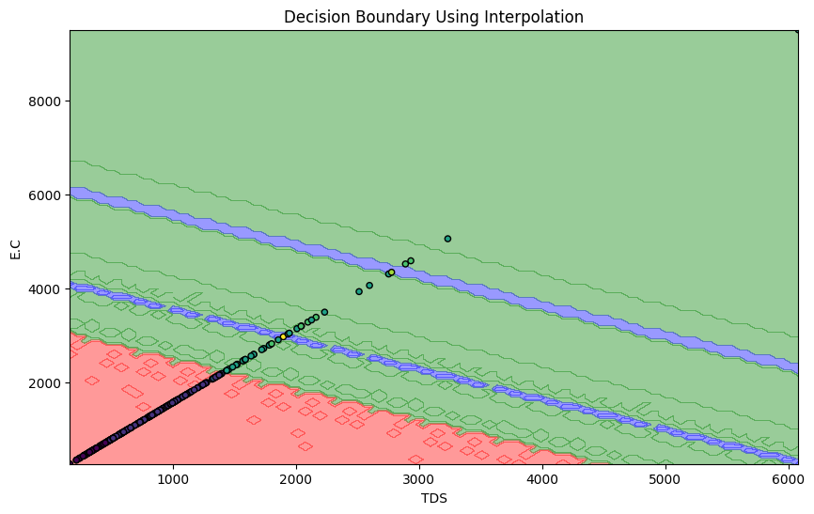

Explanation:

Feature Importance Values:
Feature Importance
9 E.C 0.242452
10 TDS 0.211156
21 T.H 0.122200
13 Cl 0.068106
17 Na 0.054199
12 HCO3 0.041792
22 SAR 0.038627
23 RSC meq / L 0.036438
20 Mg 0.035885
15 NO3 0.023854
16 SO4 0.020711
19 Ca 0.016617
14 F 0.016502
18 K 0.012628
4 lat_gis 0.008763
5 long_gis 0.008638
3 village 0.007647
2 mandal 0.006518
0 sno 0.006258
8 pH 0.005821
1 district 0.004963
6 gwl 0.004833
24 Classification.1 0.003099
11 CO3 0.002292
7 season 0.000000

Top 2 Features: ['E.C' 'TDS']

Feature Ranges for Each Region:

Red Region (0):
E.C TDS
count 66.000000 66.000000
mean 573.681818 367.156364
std 119.756954 76.644450
min 324.000000 207.360000
25% 477.000000 305.280000
50% 580.000000 371.200000
75% 678.750000 434.400000
max 745.000000 476.800000

Green Region (1):
E.C TDS
count 180.000000 180.000000
mean 1289.672222 825.390222
std 389.418487 249.227832
min 758.000000 485.120000
25% 934.000000 597.760000
50% 1258.000000 805.120000
75% 1585.000000 1014.400000
max 2188.000000 1400.320000

Blue Region (2):
E.C TDS
count 3.000000 3.000000
mean 1519.666667 972.586667
std 110.228550 70.546272
min 1394.000000 892.160000
25% 1479.500000 946.880000
50% 1565.000000 1001.600000
75% 1582.500000 1012.800000
max 1600.000000 1024.000000

Quality Classification Report:
After gathering results for this time period in the dataset it was found that the most important features for classifying water quality, were E.C. at (0.242) and TDS at (0.211) as they significantly influence the model's decision-making. E.C. which is Electrical Conductivity which being representative High conductivity in the region typically indicates the presence of dissolved salts or ions, which could signify contamination if E.C. is high as that is associated with poor water quality. Also TDS the Total Dissolved Solids Measures the concentration of dissolved solids in water; higher values usually suggest poorer water quality. Higher TDS values that exceeding 500 mg/L indicate poor water quality due to excess dissolved salts, potentially making the water unsuitable for drinking.
Lower TDS values that les than 500 mg/L suggest good water quality.

- We found for this time period was the Key Insights:
Red Region (Good):
  - Both TDS and E.C. are well within safe limits, indicating good water quality.
  - Maintain water quality by monitoring sources and avoiding potential contamination.
  - E.C. and TDS are low, which typically indicates good water quality.
  - Mean TDS (367.16 mg/L) is well below the regulatory threshold of 500 mg/L.
  - Mean E.C. (573.68 µS/cm) is also below the safe limit of 1000 µS/cm.
Conclusion:

-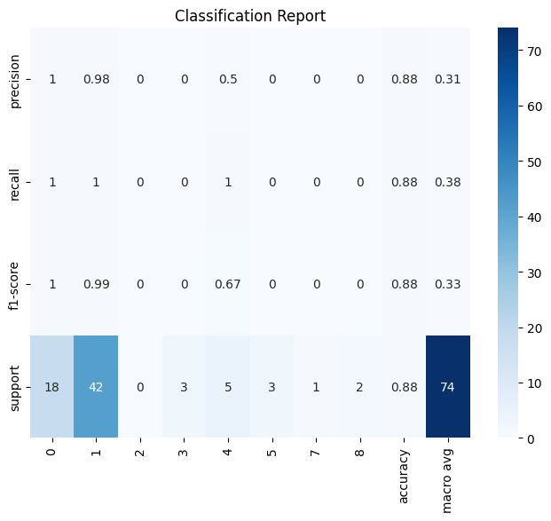

- 2019:
- Accuracy: 0.9452054794520548
- Classification Report:
- precision recall f1-score support

- 1 1.00 1.00 1.00 19
- 2 0.96 1.00 0.98 43
- 3 0.00 0.00 0.00 1
- 4 0.78 0.88 0.82 8
- 5 0.00 0.00 0.00 2

- accuracy 0.95 73
- macro avg 0.55 0.57 0.56 73
- weighted avg 0.91 0.95 0.93 73
- weighted avg 0.92 0.93 0.92 74

- Quantitative Analysis: For analysis, we would use the Area under the ROC Curve to evaluate models in addition to the accuracy percentage, precision value, recall value, and F1-score as performance metrics.

-2019:
Training Confusion Matrix:
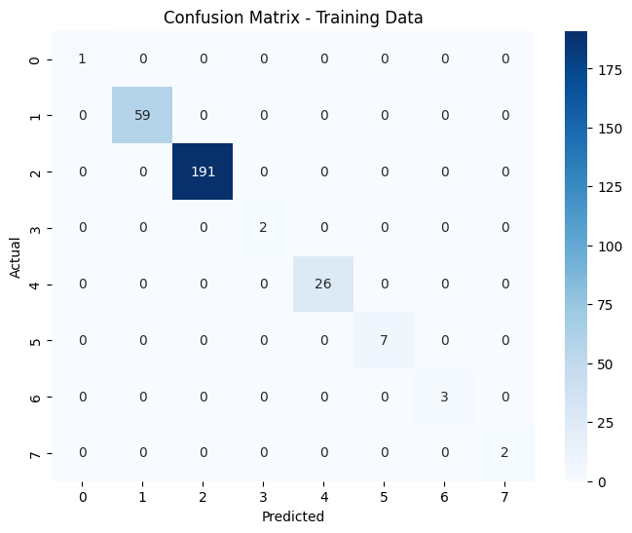
Explanation:
- The model performs exceptionally well on the training data with no misclassifications.
- However, this could indicate overfitting, especially if the test or validation confusion matrix reveals poorer performance

Test Confusion Matrix:
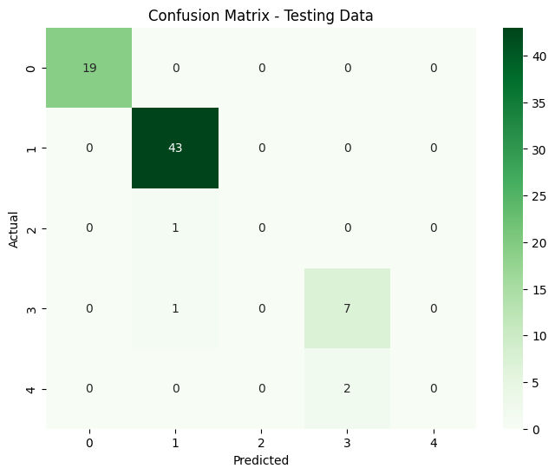
Explanation of the confusion matrix:
Strong Performance:
  - The model performs well for Classes 0, 1, and 3, with high precision and recall.
  - These classes likely have more samples in the training data or are more distinct.
Struggles with Minority Classes:
  - The model misclassifies instances of Classes 2, and 4
  - Classes 2 and 4 have no correct classifications, indicating that these classes are underrepresented in the training data or have features that overlap with other classes.

ROC Curve:
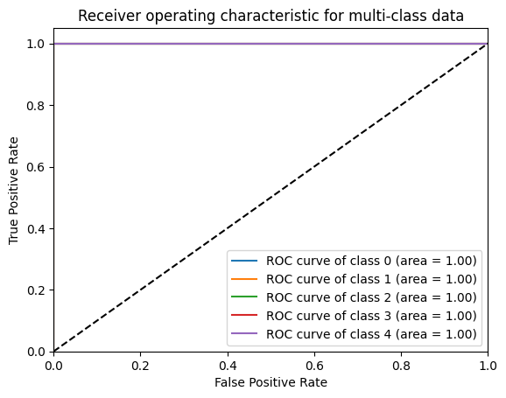
Explanation:
Maintains placement in the middle of of the graph indicating model is generalizing well good performance of a classifier and not overfitting

Feature Importance:
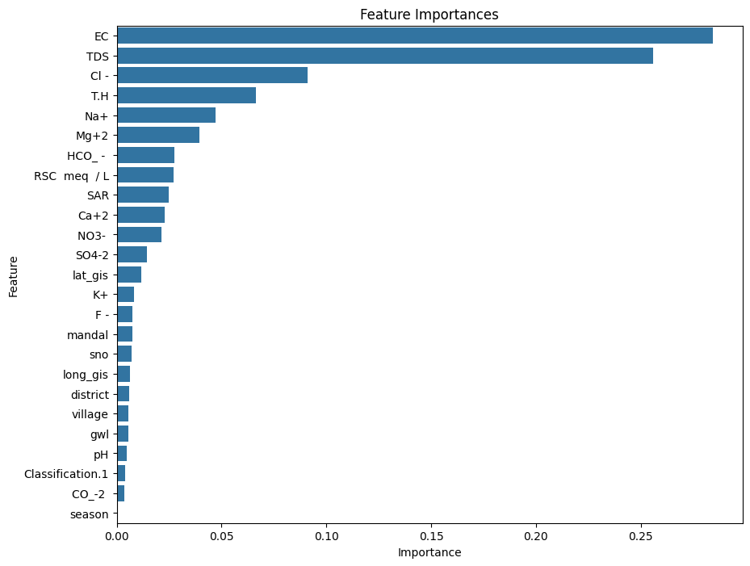

Explanation:
Top Features of Importance: EC and TDS

Learning Curve:
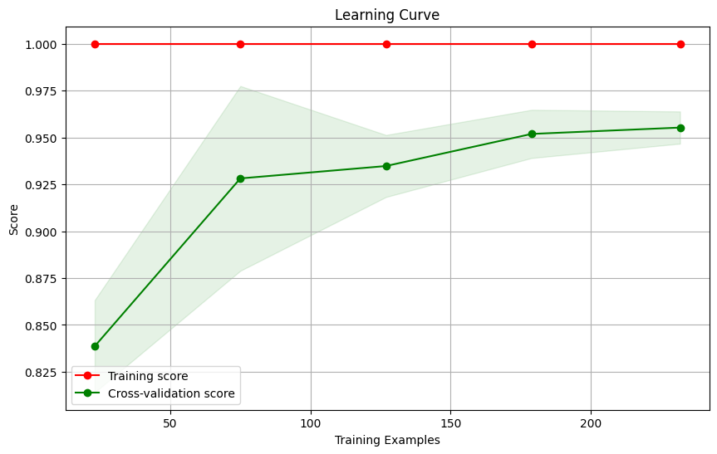
Explanation:
- High training and cross-validation scores indicate good generalization.
- A small gap between the curves suggests minimal overfitting.
- The plateau in the cross-validation score suggests the model has reached its maximum capacity, and adding more data may not provide significant improvements.
Precision Curve:

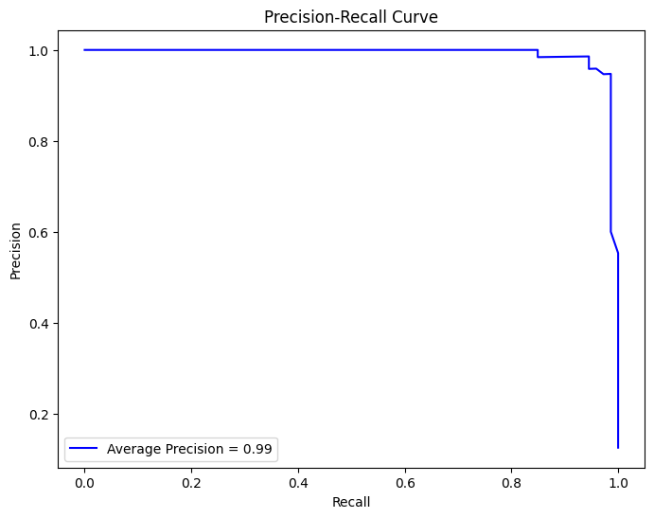
Explanation:

- Precision-Recall Curve:
  - Illustrates how the model's precision and recall vary with the classification threshold.
  - A high-performing model maintains high precision and recall, as shown here.
- Average Precision Score:
  - A score of 0.99 indicates excellent overall performance, summarizing the PR curve into a single metric.
- Micro-Averaging:
  - Aggregates performance across all classes, providing a holistic view of the classifier's behavior.

Decision Boundary:
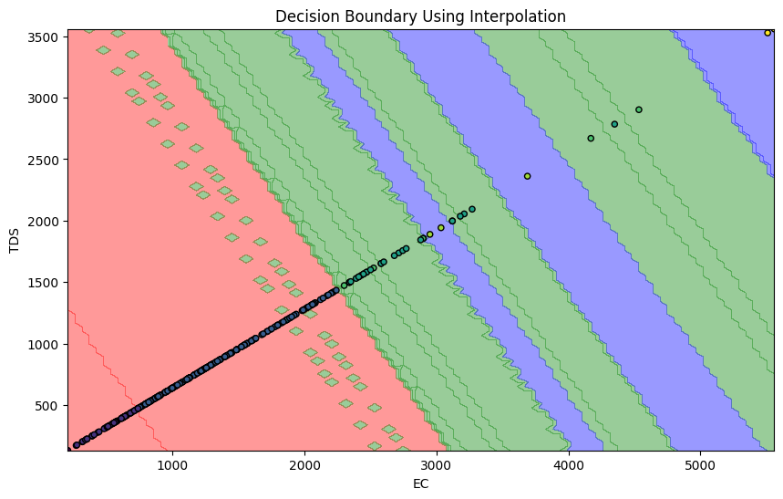
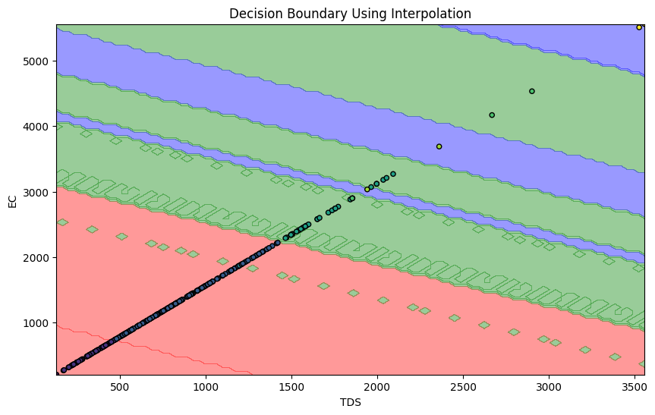

Explanation:
2019:
Feature Importance Values:
Feature Importance
10 TDS 0.276659
9 EC 0.212198
13 Cl - 0.099724
21 T.H 0.075050
17 Na+ 0.065601
12 HCO_ - 0.031949
22 SAR 0.031815
20 Mg+2 0.030432
16 SO4-2 0.029521
23 RSC meq / L 0.027389
19 Ca+2 0.022750
15 NO3- 0.019983
5 long_gis 0.010507
14 F - 0.009104
4 lat_gis 0.008648
8 pH 0.007261
1 district 0.006987
18 K+ 0.006312
0 sno 0.006293
6 gwl 0.005951
3 village 0.005834
2 mandal 0.005325
11 CO_-2 0.002425
24 Classification.1 0.002282
7 season 0.000000

Top 2 Features: ['TDS' 'EC']

Feature Ranges for Each Region:

Red Region (0):
TDS EC
count 1.0 1.0
mean 131.2 205.0
std NaN NaN
min 131.2 205.0
25% 131.2 205.0
50% 131.2 205.0
75% 131.2 205.0
max 131.2 205.0

Green Region (1):
TDS EC
count 61.000000 61.000000
mean 346.512787 541.426230
std 85.668286 133.856697
min 171.520000 268.000000
25% 277.120000 433.000000
50% 354.560000 554.000000
75% 416.000000 650.000000
max 476.160000 744.000000

Blue Region (2):
TDS EC
count 188.000000 188.000000
mean 841.004255 1314.069149
std 248.218303 387.841098
min 481.280000 752.000000
25% 640.160000 1000.250000
50% 801.920000 1253.000000
75% 1004.480000 1569.500000
max 1420.800000 2220.000000
Quality Classification Report:
After gathering results for this time period in the dataset it was found that the most important features for classifying water quality, were E.C. at (0.212) and TDS at (0.277) as they significantly influence the model's decision-making. E.C. which is Electrical Conductivity which being representative High conductivity in the region typically indicates the presence of dissolved salts or ions, which could signify contamination if E.C. is high as that is associated with poor water quality. Also TDS the Total Dissolved Solids Measures the concentration of dissolved solids in water; higher values usually suggest poorer water quality. Higher TDS values that exceeding 500 mg/L indicate poor water quality due to excess dissolved salts, potentially making the water unsuitable for drinking.
Lower TDS values that les than 500 mg/L suggest good water quality.
- We found for this time period was the Key Insights:
Red Region (Good):
  - Both TDS and E.C. are well within safe limits, indicating good water quality.
  - Maintain water quality by monitoring sources and avoiding potential contamination.
  - E.C. and TDS are low, which typically indicates good water quality.
  - Mean TDS (131.2 mg/L) is well below the regulatory threshold of 500 mg/L.
  - Mean E.C. (205. µS/cm) is also below the safe limit of 1000 µS/cm.
Conclusion:
- The Red Region likely represents good water quality

Green Region (Moderate to Poor):
  - Slightly elevated TDS and E.C. but are at moderate levels.
  - E.C. and TDS are moderate to high, suggesting some degree of contamination.
  - Mean TDS (346.51 mg/L) is below the safe threshold of 500 mg/L.
  - Mean E.C. (541.43 µS/cm) is below 1000 µS/cm, indicating acceptable salinity levels.
  - The ranges for both features indicate water that is safe for consumption or use, though it may require monitoring for salinity changes.
Conclusion:
- The Green Region indicates good water quality, as all values fall within acceptable ranges.

Blue Region (Poor):
  - Significantly elevated TDS and E.C. values indicate contamination and poor water quality.
  - Which indicates the need to treat water to reduce TDS and E.C. levels Identify and address contamination sources to improve water quality
  - E.C. and TDS are very high, indicating significant contamination.
  - Mean TDS (841.00 mg/L) exceeds the safe threshold of 500 mg/L, indicating contamination from dissolved solids.
  - Mean E.C. (1314.07 µS/cm) is above 1000 µS/cm, signifying high salinity or ionic contamination.
  - The ranges suggest poor water quality, potentially unsuitable for drinking or agricultural use without treatment.
Conclusion:
- The Blue Region represents poor water quality
  - .
Large Concentration of data points lie in the Red and and Green Regions indicating overall good to moderate quality of water for this Time period.
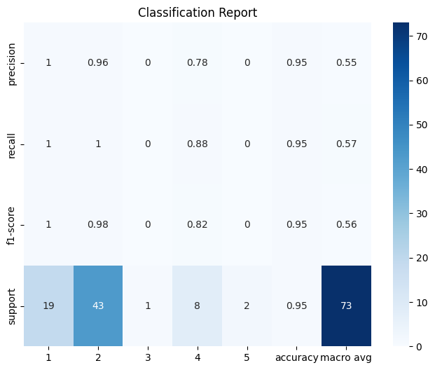

- 2018:
- Accuracy: 0.92
- Classification Report:
- precision recall f1-score support

- 1 1.00 1.00 1.00 14
- 3 0.98 1.00 0.99 51
- 4 0.00 0.00 0.00 0
- 5 0.00 0.00 0.00 2
- 7 0.60 1.00 0.75 3
- 8 0.00 0.00 0.00 2
- 10 1.00 0.33 0.50 3

- accuracy 0.92 75
- macro avg 0.51 0.48 0.46 75
- weighted avg 0.92 0.92 0.91 75

- Quantitative Analysis: For analysis, we would use the Area under the ROC Curve to evaluate models in addition to the accuracy percentage, precision value, recall value, and F1-score as performance metrics.

-2018:
Training Confusion Matrix:
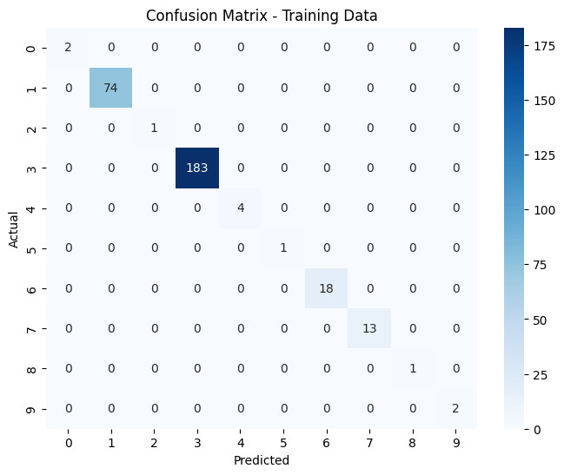
Explanation:
- The model performs exceptionally well on the training data with no misclassifications.
- However, this could indicate overfitting, especially if the test or validation confusion matrix reveals poorer performance

Test Confusion Matrix:
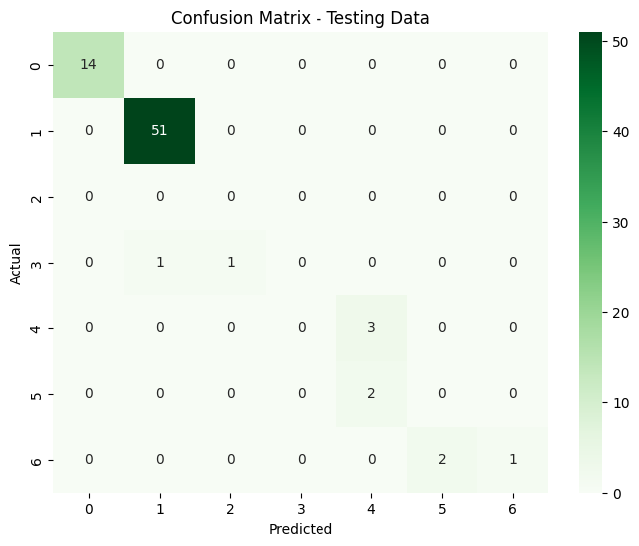
Explanation of the confusion matrix:
Strong Performance:
  - The model performs well for Classes 0, 1, and 4 with high precision and recall.
  - These classes likely have more samples in the training data or are more distinct.
Struggles with Minority Classes:
  - The model misclassifies instances of Classes 4, and 1,.
  - Classes 3,5 and 6 having little to no correct classifications, indicating that these classes are underrepresented in the training data or have features that overlap with other classes.

ROC Curve:
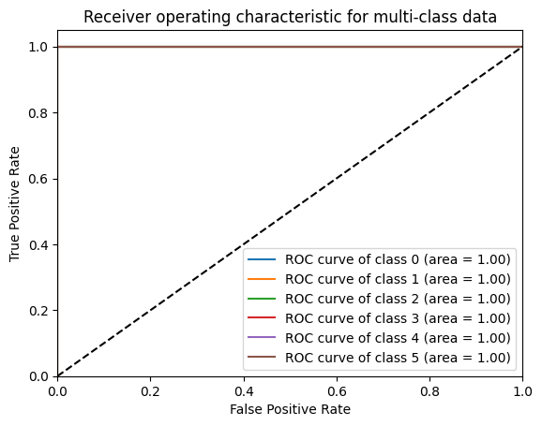
Explanation:
Maintains placement in the middle of of the graph indicating model is generalizing well good performance of a classifier and not overfitting

Feature Importance:
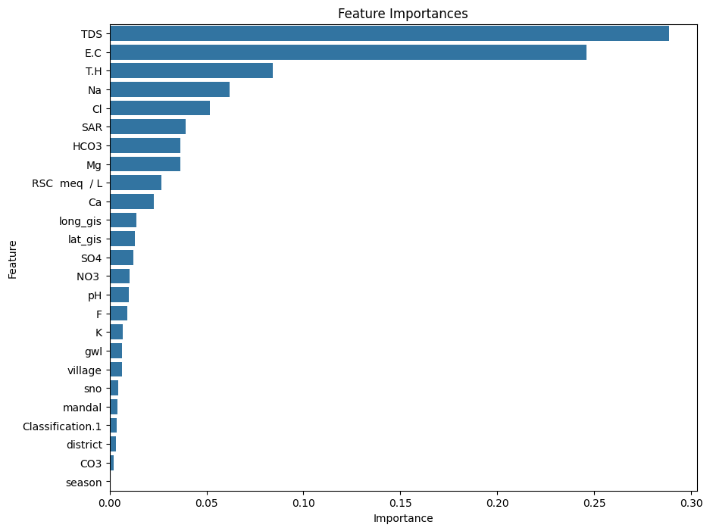
Explanation:
Top Features of Importance: TDS and EC

Learning Curve:
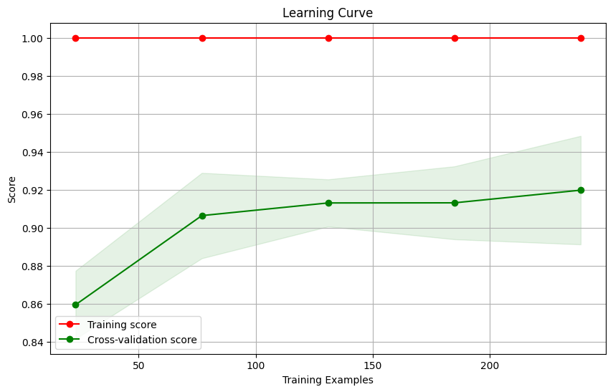
Explanation:

- High training and cross-validation scores indicate good generalization.
- A small gap between the curves suggests minimal overfitting.
- The plateau in the cross-validation score suggests the model has reached its maximum capacity, and adding more data may not provide significant improvements.
Precision Curve:

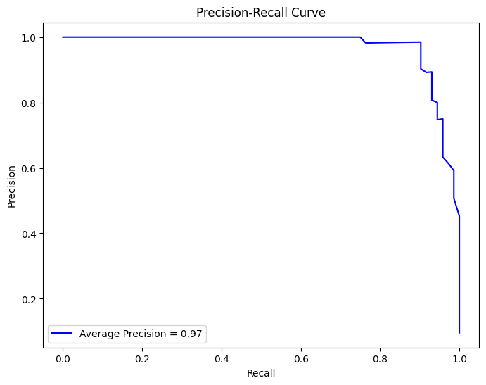
Explanation:
- Precision-Recall Curve:
  - Illustrates how the model's precision and recall vary with the classification threshold.
  - A high-performing model maintains high precision and recall, as shown here.
- Average Precision Score:
  - A score of 0.97 indicates excellent overall performance, summarizing the PR curve into a single metric.
- Micro-Averaging:
  - Aggregates performance across all classes, providing a holistic view of the classifier's behavior.

Decision Boundary:
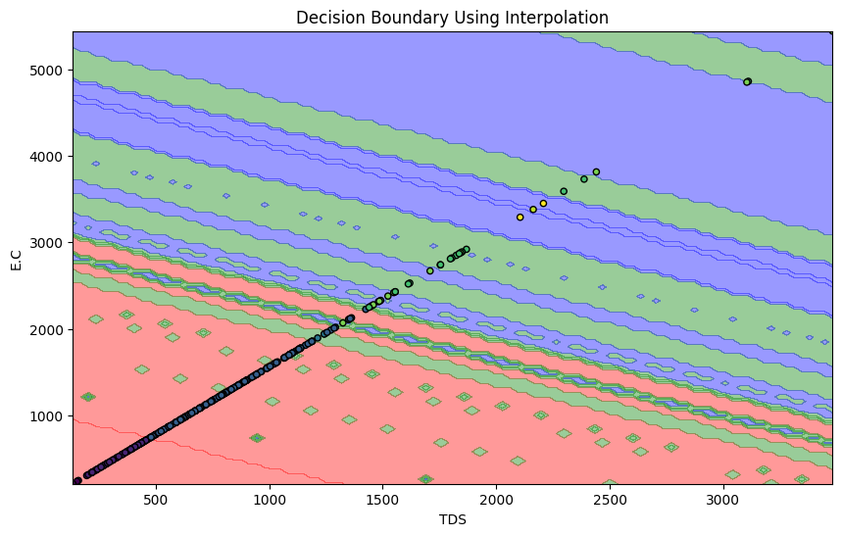
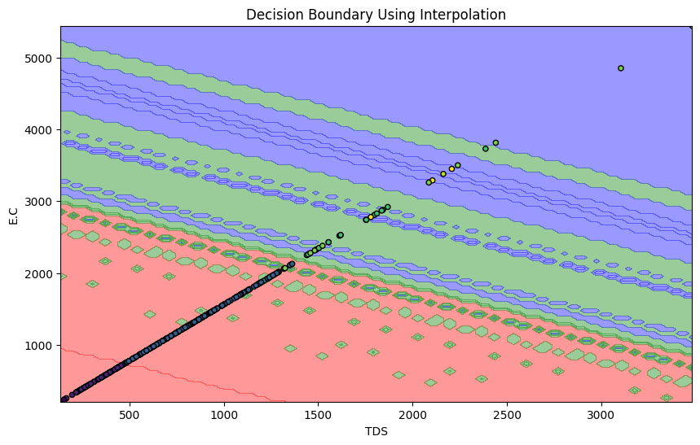

Explanation:
2018:
Feature Importance Values:
Feature Importance
10 TDS 0.228785
9 E.C 0.223455
21 T.H 0.105367
17 Na 0.083177
13 Cl 0.079845
20 Mg 0.040325
22 SAR 0.039586
23 RSC meq / L 0.034046
12 HCO3 0.032281
19 Ca 0.018614
15 NO3 0.016766
14 F 0.015999
16 SO4 0.013833
5 long_gis 0.009041
8 pH 0.009019
2 mandal 0.007257
4 lat_gis 0.007185
18 K 0.006825
6 gwl 0.006354
24 Classification.1 0.005835
3 village 0.005322
0 sno 0.004688
1 district 0.003390
11 CO3 0.003002
7 season 0.000000

Top 2 Features: ['TDS' 'E.C']

Feature Ranges for Each Region:

Red Region (0):
TDS E.C
count 2.000000 2.00000
mean 144.640000 226.00000
std 12.671354 19.79899
min 135.680000 212.00000
25% 140.160000 219.00000
50% 144.640000 226.00000
75% 149.120000 233.00000
max 153.600000 240.00000

Green Region (1):
TDS E.C
count 77.000000 77.000000
mean 351.177143 548.714286
std 88.751827 138.674729
min 160.000000 250.000000
25% 270.080000 422.000000
50% 371.200000 580.000000
75% 431.360000 674.000000
max 479.360000 749.000000

Blue Region (2):
TDS E.C
count 1.0 1.0
mean 476.8 745.0
std NaN NaN
min 476.8 745.0
25% 476.8 745.0
50% 476.8 745.0
75% 476.8 745.0
max 476.8 745.0

Quality Classification Report:
After gathering results for this time period in the dataset it was found that the most important features for classifying water quality, were E.C. at (0.223) and TDS at (0.229) as they significantly influence the model's decision-making. E.C. which is Electrical Conductivity which being representative High conductivity in the region typically indicates the presence of dissolved salts or ions, which could signify contamination if E.C. is high as that is associated with poor water quality. Also TDS the Total Dissolved Solids Measures the concentration of dissolved solids in water; higher values usually suggest poorer water quality. Higher TDS values that exceeding 500 mg/L indicate poor water quality due to excess dissolved salts, potentially making the water unsuitable for drinking.
Lower TDS values that les than 500 mg/L suggest good water quality.
- We found for this time period was the Key Insights:
Red Region (Good):
  - Both TDS and E.C. are well within safe limits, indicating good water quality.
  - Maintain water quality by monitoring sources and avoiding potential contamination.
  - E.C. and TDS are low, which typically indicates good water quality.
  - Mean TDS (144.64 mg/L) is well below the regulatory threshold of 500 mg/L.
  - Mean E.C. (226. µS/cm) is also below the safe limit of 1000 µS/cm.
Conclusion:
- The Red Region likely represents good water quality

Green Region (Moderate to Poor):
  - Slightly elevated TDS and E.C. but are at moderate levels.
  - E.C. and TDS are moderate to high, suggesting some degree of contamination.
  - Mean TDS (351.18 mg/L) is below the safe threshold of 500 mg/L.
  - Mean E.C. (548.71 µS/cm) is below 1000 µS/cm, indicating acceptable salinity levels.
  - The ranges for both features indicate water that is safe for consumption or use, though it may require monitoring for salinity changes.
Conclusion:
- The Green Region indicates good water quality, as all values fall within acceptable ranges.

Blue Region (Moderate):
  - TDS and E.C. values are nearing the upper safe limits.
  - While still within acceptable ranges, the water may require monitoring to prevent further degradation
  - TDS (Mean: 476.80 mg/L) and E.C. (Mean: 745 µS/cm) are on the higher end but still within acceptable limits.
  - While the values are close to the thresholds for safe water quality, they are not extreme.
Conclusion:
- The Blue Region represents moderate water quality and may require closer monitoring to ensure it does not degrade.

Large Concentration of data points lie in the Red and and Blue Regions but water overall during this Time period maintained good to moderate quality.

Overall Water Quality from 2018-2020:
While data point show that over the years the consistently lied in areas where there were consistent good to moderate water like red and green the areas were there moderate to poor quality of water had to continual decline. Starting off in 2018 with no contamination concerns, 2019 showed increases in salinity levels, ionic containat, and contamination from dissolved solids as TDS exceeded and EC exceeded threshold levels. As well in but overall water quality was good, 2020 showed increases in salinity levels, ionic containat, and contamination from dissolved solids as TDS exceeded and EC exceeded threshold levels. The Green Region shows a gradual decline, with moderate contamination observed by 2020. The Blue Region shifts from moderate to poor quality, indicating severe contamination. The deterioration in the Blue and Green Regions suggests increasing contamination from industrial, agricultural, or urban runoff.
